**LAB 05**



# Spring 2024

Submitted by: **Hassan Zaib Jadoon**

Registration No: **22pwcse2144**

Class Section: **A**

“On my honor, as student of University of Engineering and Technology, I have neither given nor received unauthorized assistance on this academic work.”

Submitted to:

# Engr. Usman Malik

Month Day, Year ( 26, 2024)

Department of Computer Systems Engineering University of Engineering and Technology, Peshawar

**Lab 05**

**Task 01:**

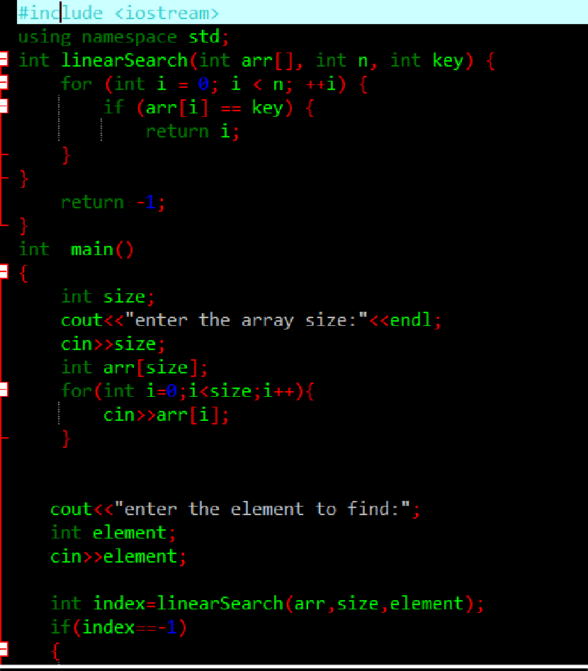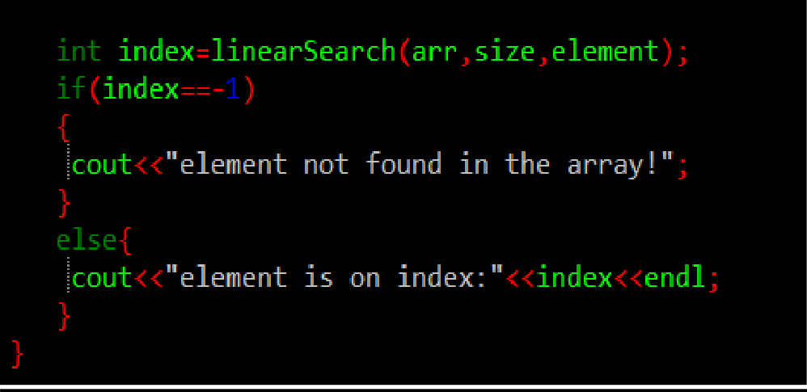

**Output:**

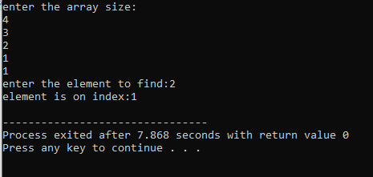

**Task 02:**

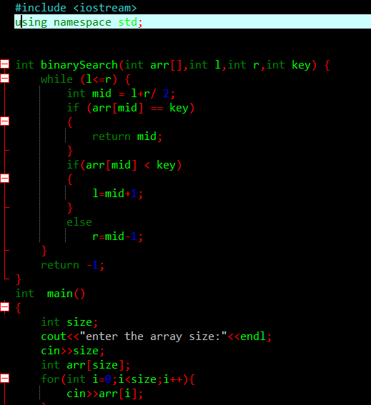

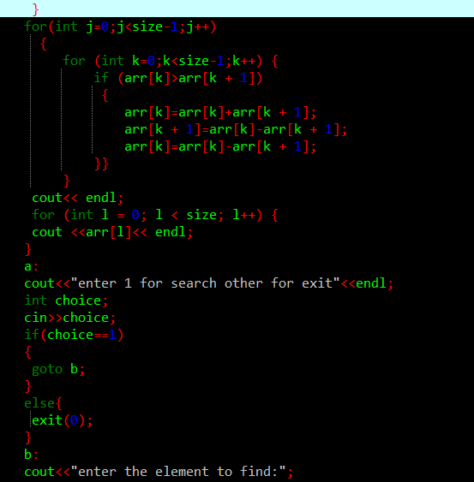

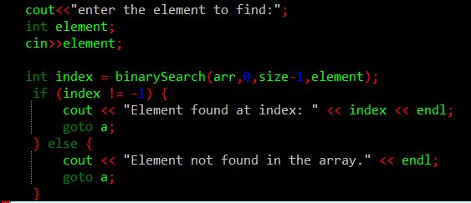

**Output:**

